CP2501 summary

In the summer of 2025 at the Pee Dee Research and Education Center in Florence, SC, a cowpea variety trial was conducted to investigate the resistance or susceptibility of 15 cowpea varieties (Table 1) to the insect pest, cowpea curculio (Chalcodermus aeneus). The varieties included in this trial were selected based on improved heat tolerance, resistance to biotic stressors, plant architecture, and popularity for production in SC. The 15 varieties in this study were evaluated in 25 ft single-row plots in a randomized complete block experimental design with 4 replications. The trial was planted on April 29, 2025.

When seeds reached succulent maturity, 10 plants from the middle of each plot were hand-harvested and used for data collection. The traits recorded are stand count, date to first flower, date to 50% flowering, harvest date, pod position, number of mature pods, number of immature pods, number of dry pods, number of diseased pods, weight of mature pods (g), weight of immature pods (g), number of seed from 10 mature pods, weight of seed from 10 mature pods, number of punctured seed from 10 mature pods, and seed eye color.

All cowpea varieties included in this study sustained damage from cowpea curculio when assessing the number of seeds that were damaged from 10 pods (Fig.1).

Location: Field 20, Pee Dee Research and Education Center, Florence, SC

Field Design:
- Experimental Design: randomized complete block design (RCBD) 4 replications
- Single Row Plots
- Plot Length: 25 ft (7.6 m)
- Row Spacing: 38 in (0.91 m)
- Alley Length:
- Seed Spacing: 3 in
- Seeding Rate: 4 seed/ft
- Seeds per plot: 100 seed
- Total Seed per Accession: 400 seed (100 seed/plot * 4 replicates)
- Sowing Depth: 1 in

Varieties:
Table 1: List of varieties and their seed source
Variety | Seed Source
Coronet Pinkeye Purplehull | Kelly Seed - Dillon
Papago Tohono O'odham | Southern Exposure Seed Exchange
Mississippi Purplehull Pea | Hoss
Kiawah Pinkeye Purple Hull | Southern Exposure Seed Exchange
Knucklehull-VNR | Southern Exposure Seed Exchange
Cowpea Phenomenal | Harris Seed Co.
Texas Big Boy Pea | Hoss
Dixie Lee Pea | Kelly Seed - Dillon
Top Pick Pinkeye Pea | Hoss
Zipper Cream | Southern Exposure Seed Exchange
Hercules | Southern Exposure Seed Exchange
Big Red Ripper | Southern Exposure Seed Exchange
Green Dixie Blackeye | Southern Exposure Seed Exchange
Carolina Crowder | Southern Exposure Seed Exchange
Bettersnap | Southern Exposure Seed Exchange

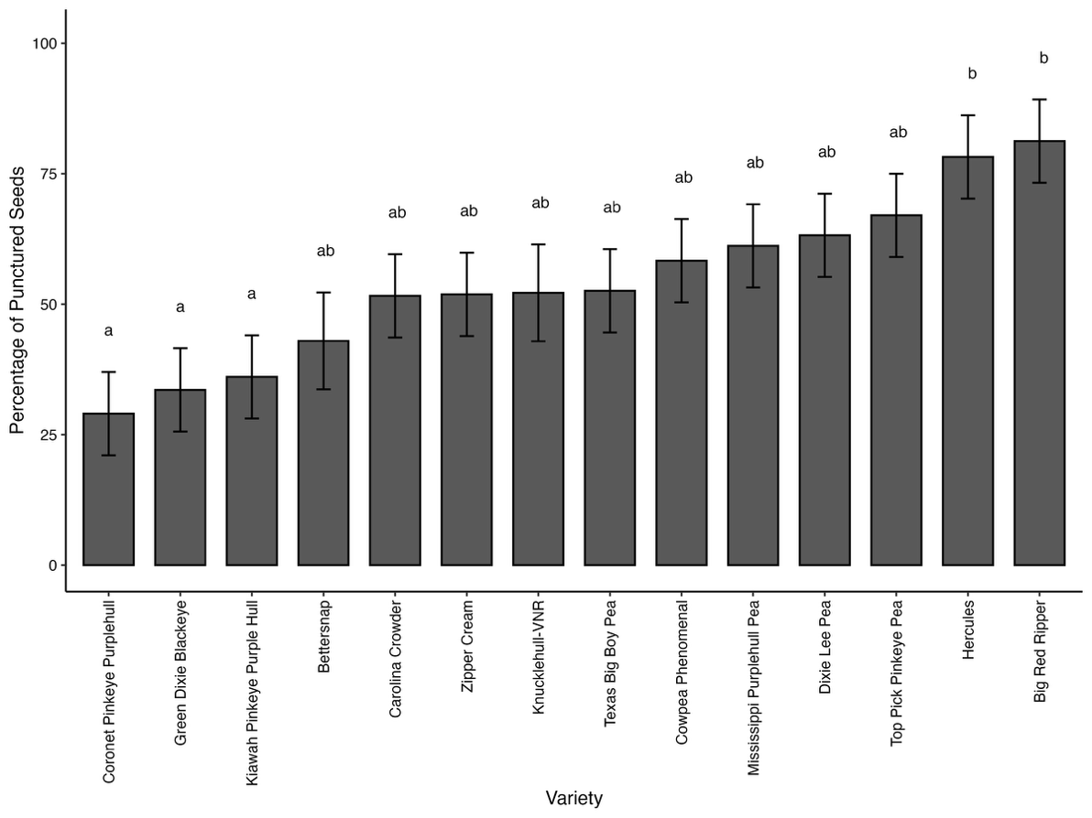
Fig.1. The percentage of punctured seeds harvested from 10 pods.

